[QB Carnival 2025 by RyanXee (Sven's SudokuPad v0.587.0)](https://sudokupad.app/jv4u4akvyz)

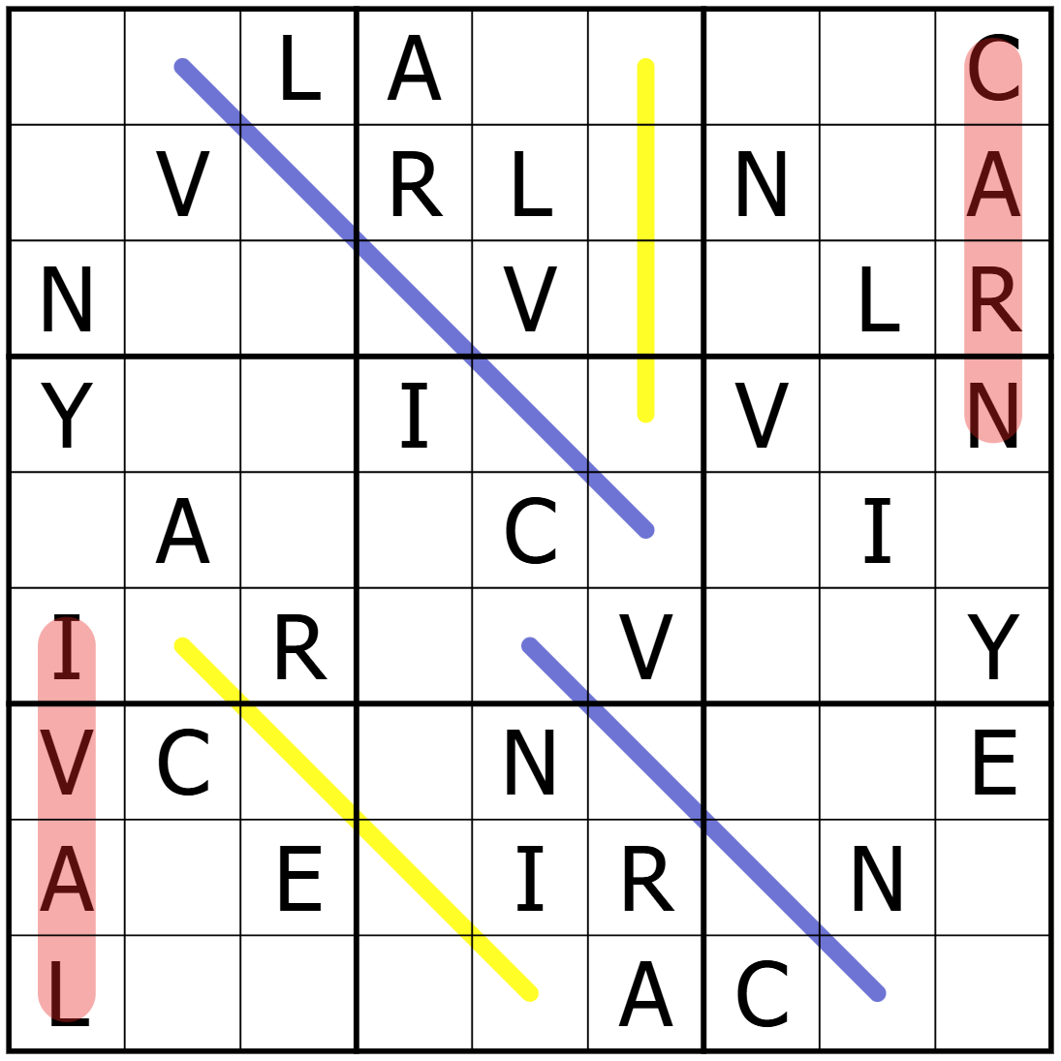

0523奚瑞阳